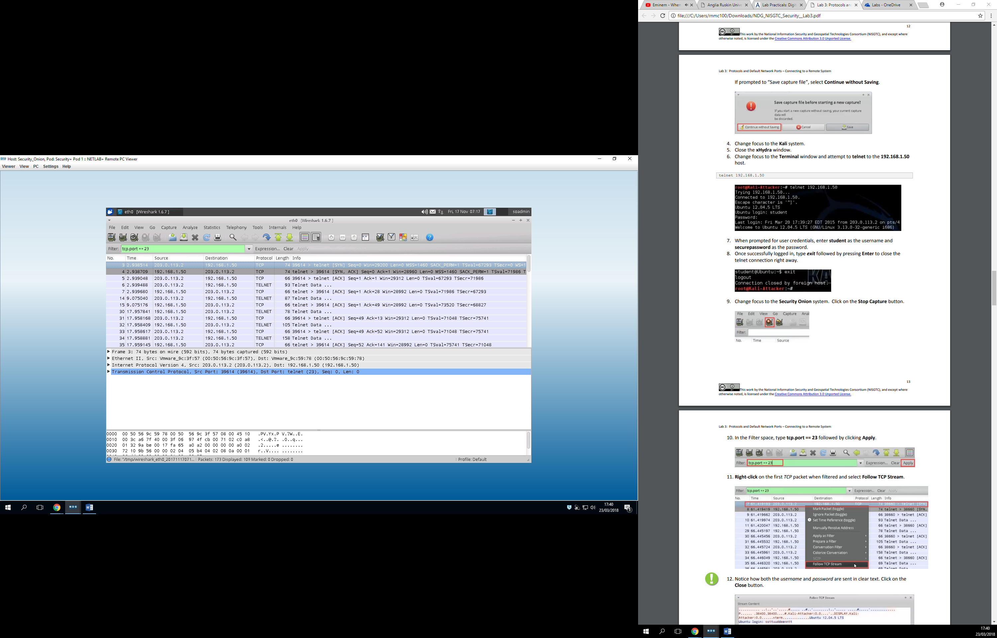

Here we have captured the movement from Kali, which was recorded unto wireshark, because Kali tried to access the passwords. And when you access passwords the movement is pretty “Loud”.

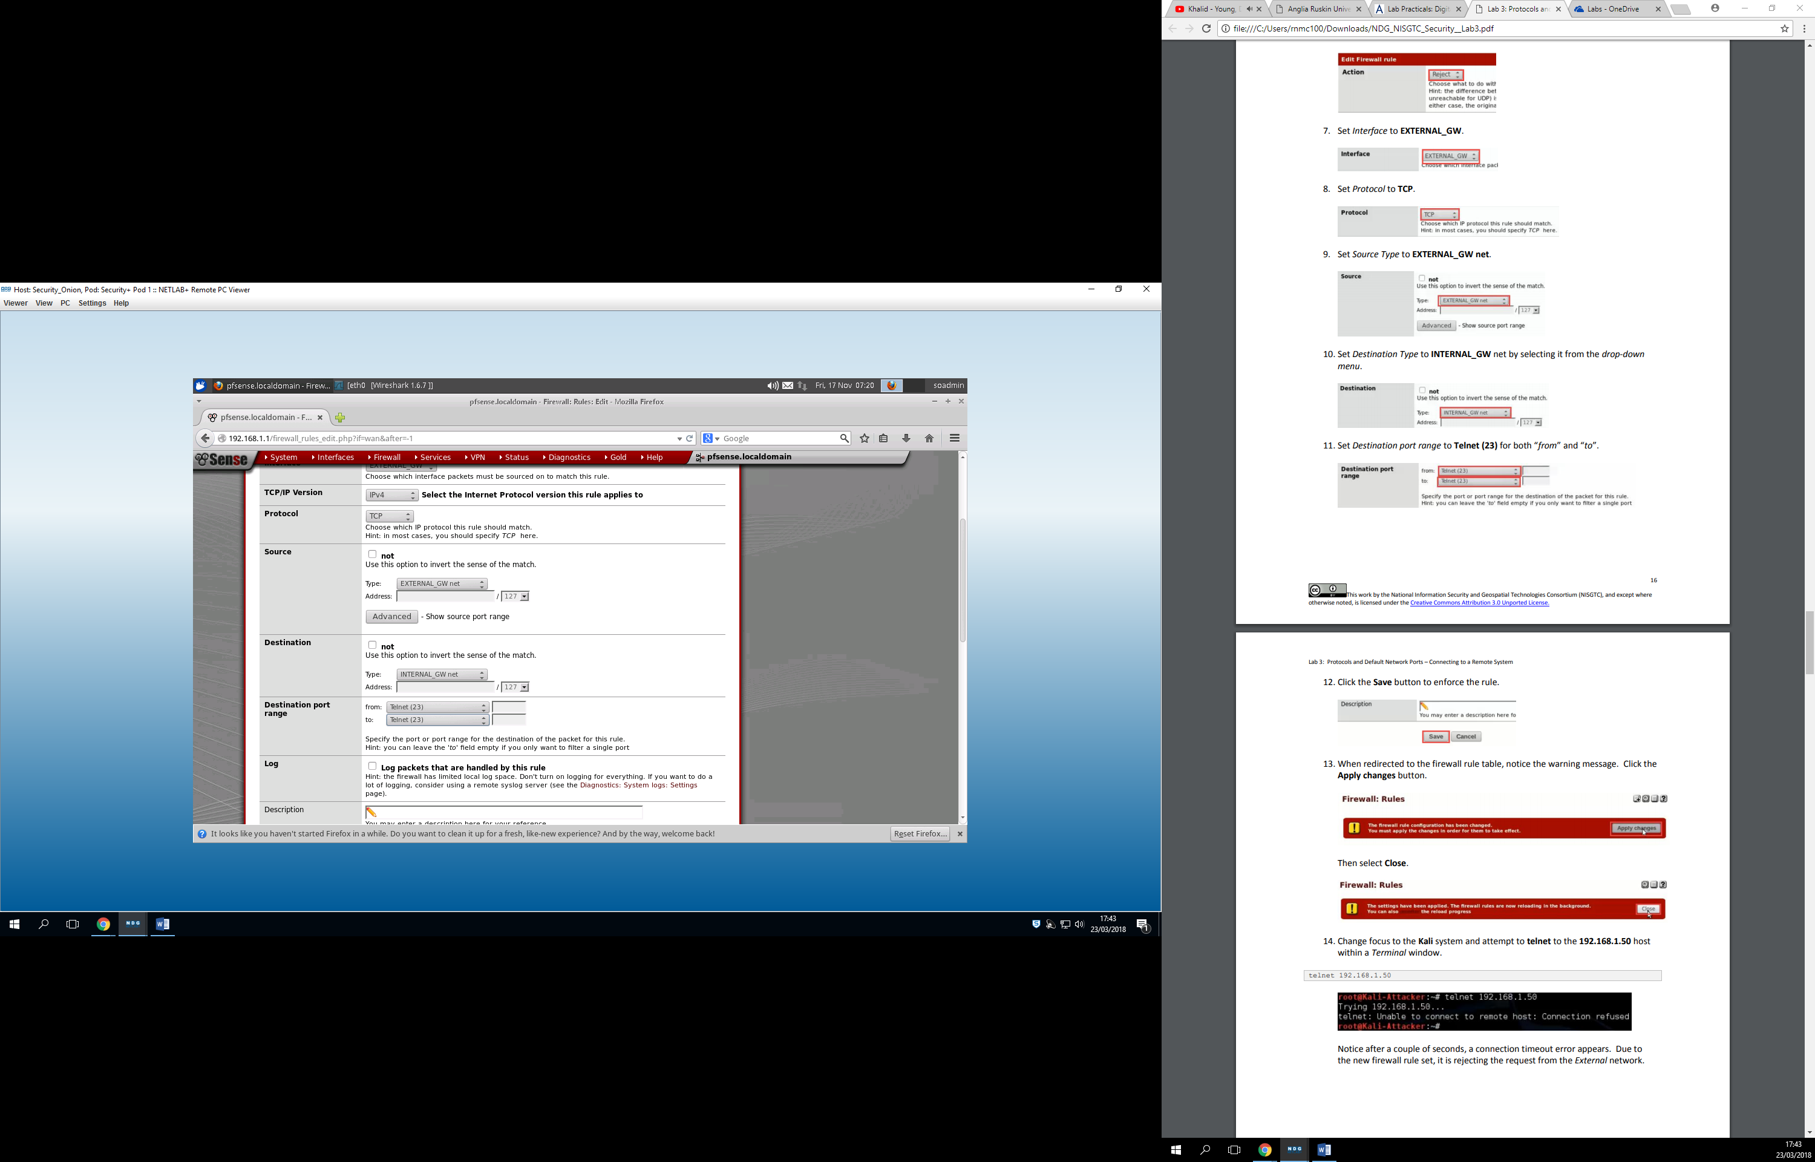

In the meanwhile we changed the firewall rules, and now when we try to access 192.168.1.50, it rejects Kali. 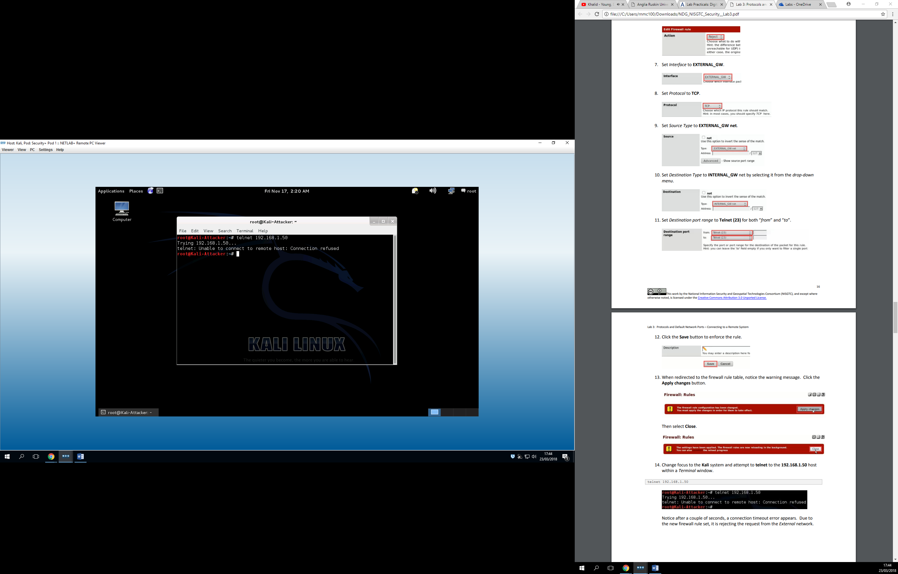

Admin created here

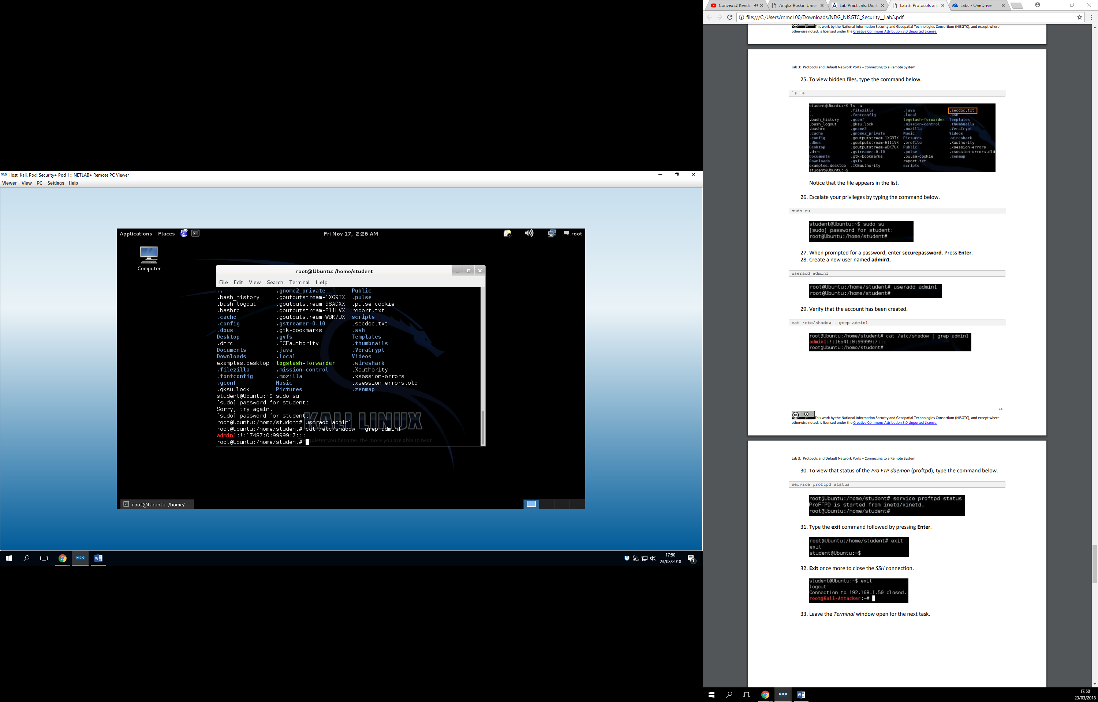

Here Kali is connected to Security onions Shell

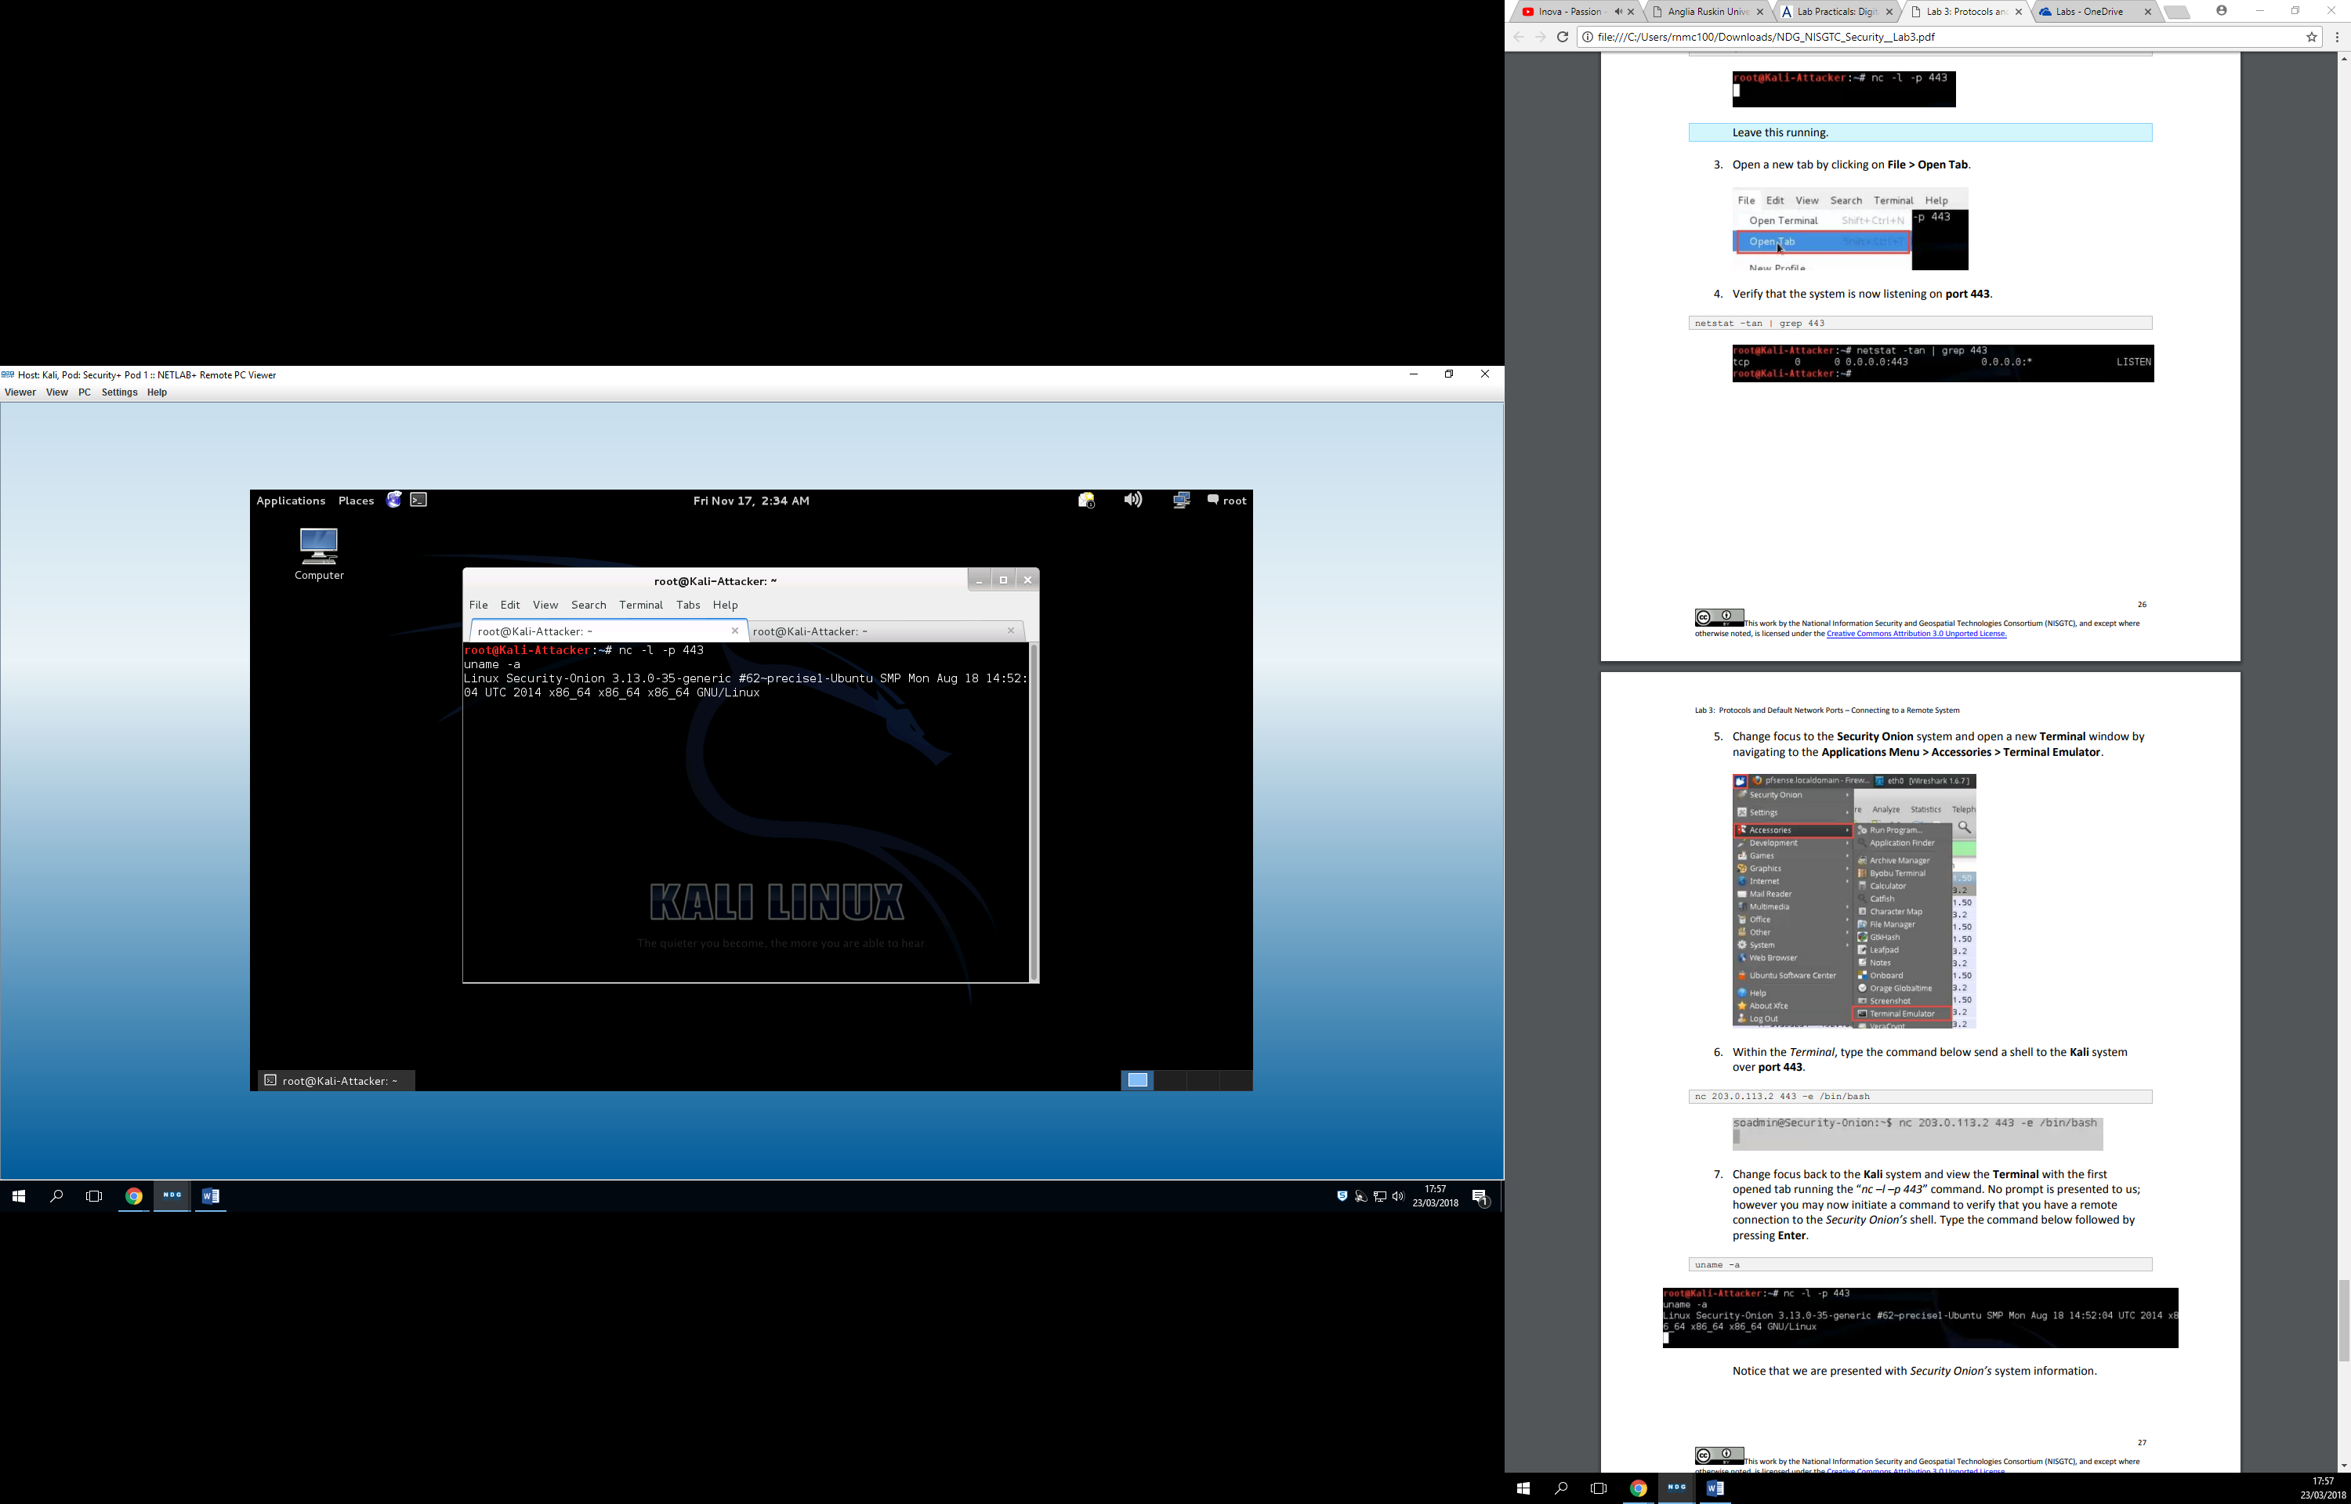

Connection established 